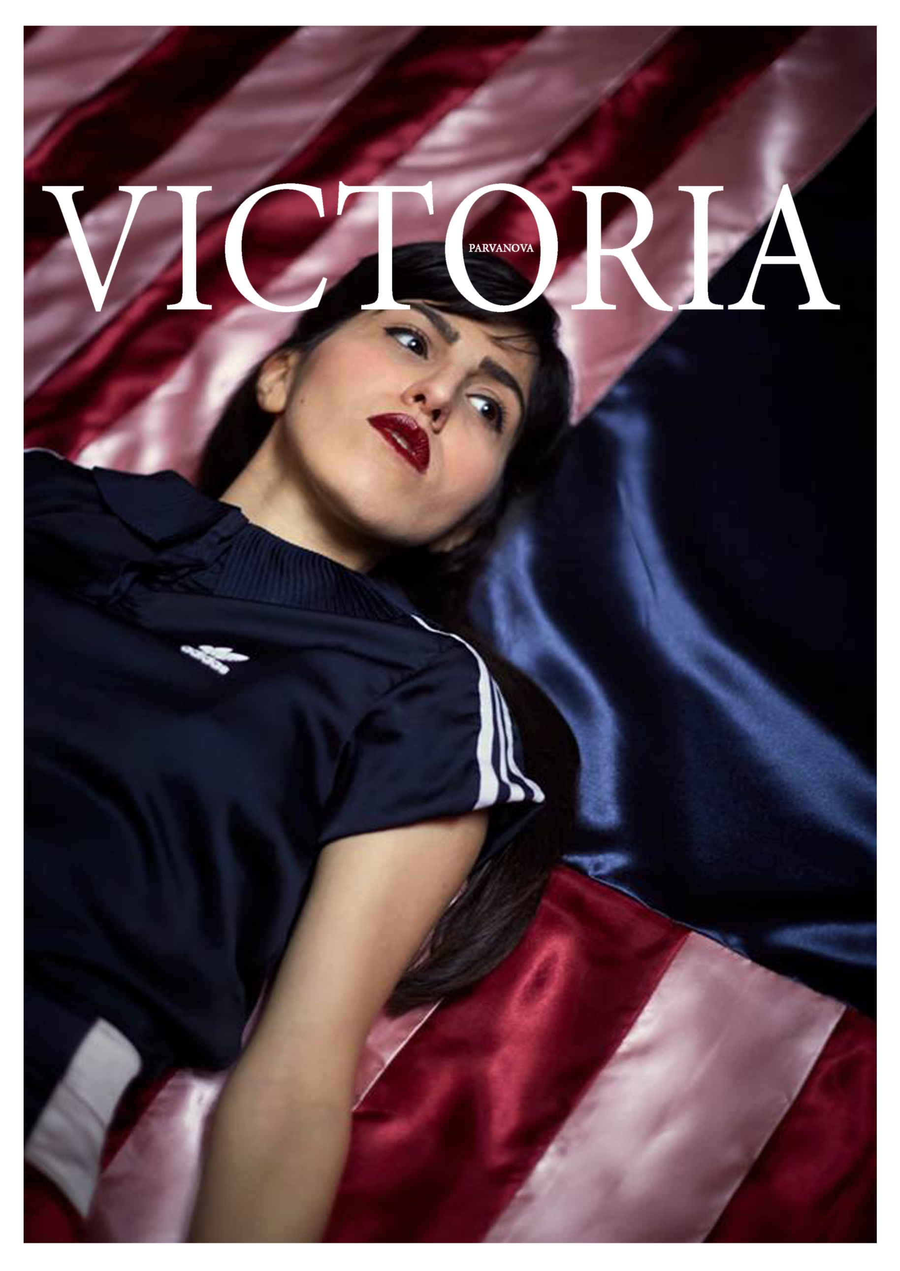

Ambtman straat 6, 2000 Antwerp
0497781245
vikiparvanova@abv.bg
Bulgarian
03.03.1993
Female

Education and training
2016-2018
Master in the Fine Arts, Painting
Royal Academy of Fine Arts, Antwerp
Blindestraat 35, 2000 Antwerp

2013-2016
Bachelor in Painting
Royal Academy of Fine Arts, Antwerp
Blindestraat 35, 2000 Antwerp

2008-2012
Fashion Designer
Vocational High School of Clothing and Design “Princess Maria Luisa”
Bul. Cherni Vrah 37, Sofa, Bulgaria

Mother tongue: Bulgarian
Other languages: English – advanced,
Dutch advanced, French-medial, Italian- A1

Exhibitions
2018 Bob's your uncle, at Showhouse JayJay, Antwerp
2017 No Time, Academy of Fine Art Antwerp, Lange Zaal
2017 Masters 2017, Antwerp, Campus Paardenmarkt
2016 Etage 22, Antwerp, Antwerp Tower
Award
2017 Award of the Academy for Painting

